**Links to C development software:**

Dev C++ can be downloaded from the following page:

<http://sourceforge.net/projects/orwelldevcpp/files/Portable%20Releases/>

A free version of Microsoft Visual C++ compiler (Visual C++ Express) can be downloaded from the site below:

<http://www.visualstudio.com/en-us/products/visual-studio-express-vs.aspx>

In this class I will use Dev C++

**How to compile and execute the program using Dev-C++:**

After downloading and installing Dev C++:

1. Launch Dev-C++ (Start menu -> All Programs -> Bloodshed Dev-C++ -> Dev-C++ )

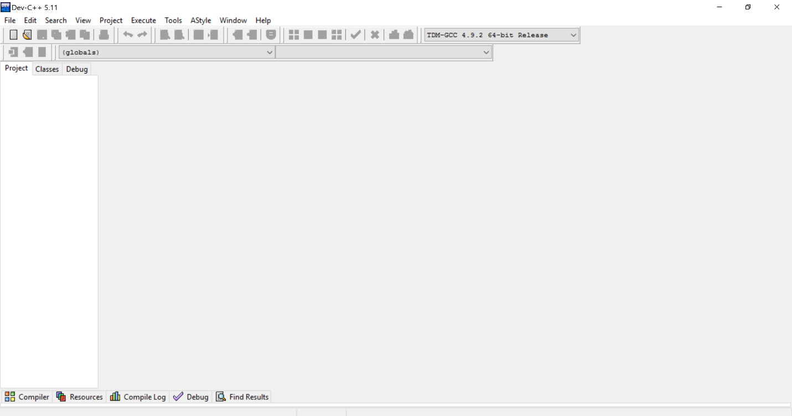

1. Click on "File -> New Project" to open the "New Project" dialog box

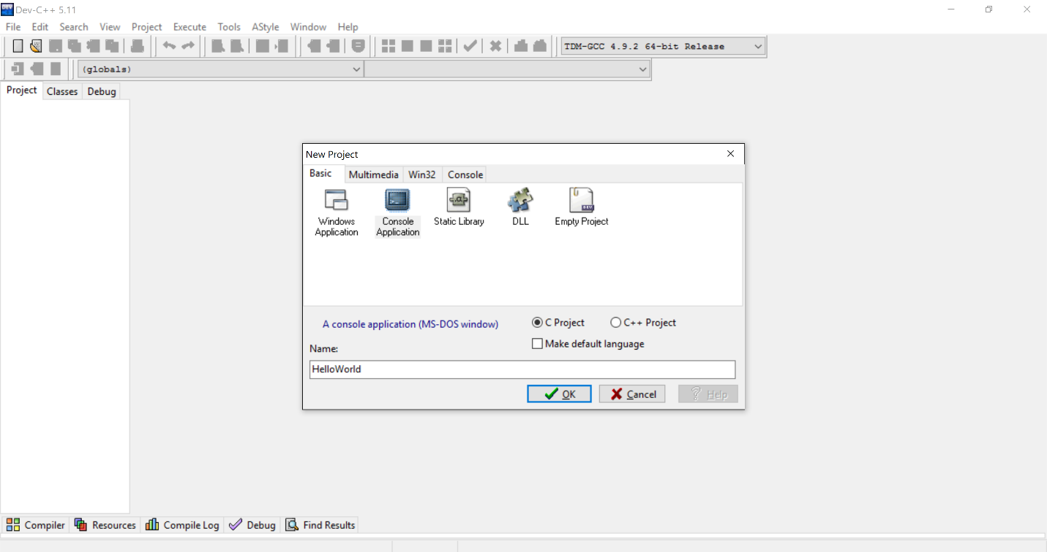

1. Select the "Console Application" project type and the "C project" option. Click "OK" to close the dialog.
2. Give the project a name and save it in its own folder, preferably with the same name as the name of the project.
3. Give the C source file a name and save it. The file name "main.c" will be used by default.
4. Type the following line in your code (right below the opening curly brace) as shown in the figure below.

***printf( "Hello World\n" );***

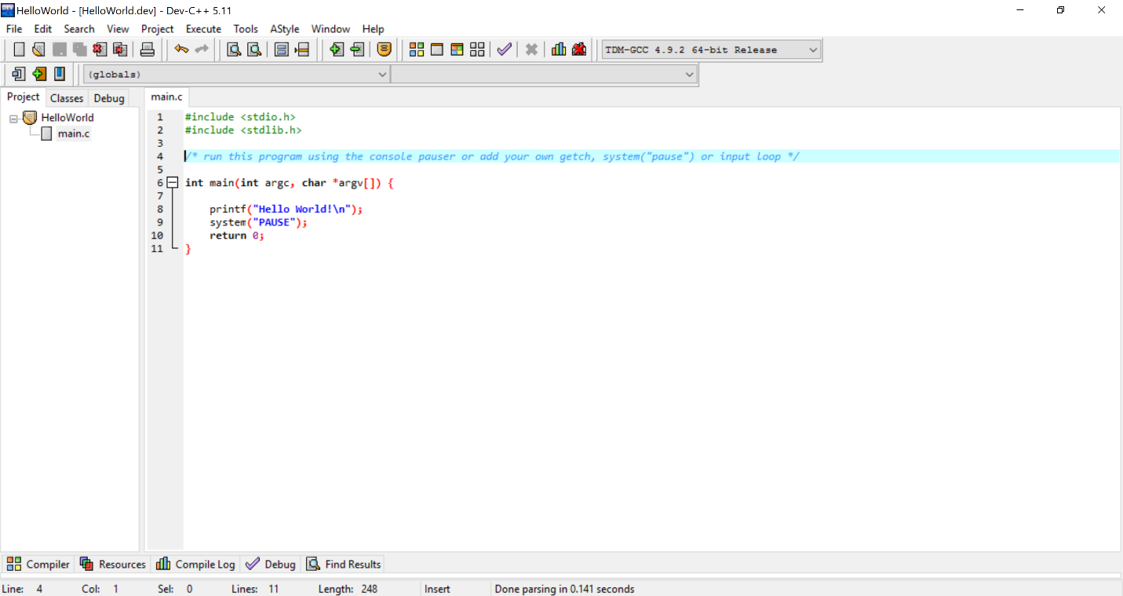

1. Click on the "Execute -> Compile" menu to compile the project.
2. Click on the "Execute -> Run" menu to run the program.

**Note:** To compile using gcc, run the following command on the command line:

gcc –o <output_file> <input_file>

To execute the program on the command line, just enter the output_file name.

